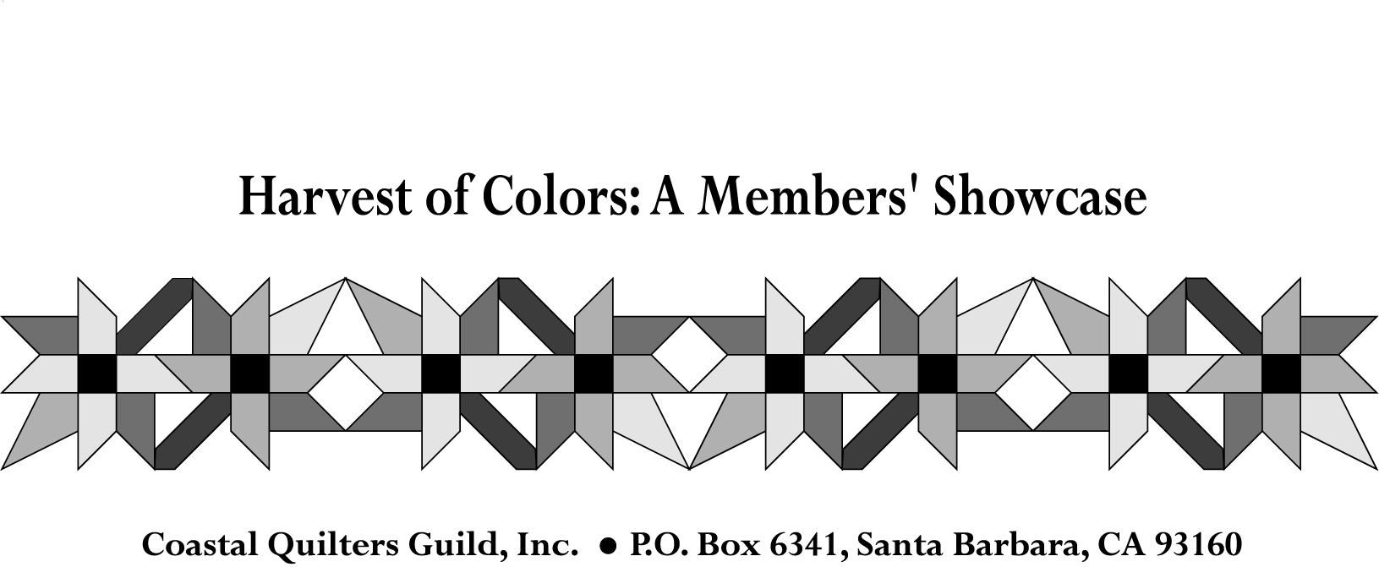

June 30, 2010

For Immediate Release:

QUILT SHOW TO SHOWCASE OVER 2OO GUILD MEMBERSHIP QUILTS

The 2010 “Harvest of Colors: A Members’ Showcase” Quilt Show, sponsored by the Coastal Quilters Guild of Santa Barbara and Goleta, California, will feature over 200 guild members’ quilted creations and promises to be spectacular.
The biennial show will be held the weekend of September 25 and 26 at the Earl Warren Showgrounds, Hwy101 and Las Positas, in Santa Barbara and will run from 10 AM to 5 PM both days. Weekend passes, good for both days, are $8 in advance and $10 at the door, children under 18 will be allowed in for free. Advance tickets can be ordered on the guild’s website, www.coastalquilters.org . Free parking will also be available thanks to Planned Parenthood’s annual book sale, also being held at the fairgrounds that weekend.
The show will have on display traditional quilts, art quilts, quilted wearables and for the first time - quilted home decor. Visitors to the show will be able to vote for their favorite quilt in the “Viewer’s Choice”. The Education Corner will have activities for both children and adults alike. Quilting demonstrations also will take place throughout the weekend. A gift boutique will have hand-crafted items for sale and 21 vendors will participate in the merchant mall.
Norah McMeeking, a Santa Barbara resident and an internationally renowned quilt artist, designer, author and instructor is the show’s featured artist. Norah will be displaying many of her quilts and will be giving quilting technique demonstrations.
Norah also made for the guild this year’s “Opportunity” quilt. A photo of the “Roman Autumn” quilt can be found on the guild’s web site at http://www.coastalquilters.org/opportunity.html . Tickets for the raffle are $1 each or six for $5 and will be available at the show. The drawing for the quilt will be December 10, 2010 and the winner need not be present to win.
Proceeds from the opportunity quilt and the show go to help fund many of the guild’s community projects. Recent recipients of the guild’s generosity include the Assistance League of Santa Barbara, Hospice, St. Andrews Presbyterian Church, Goleta Valley Community Center, the Breast Cancer Treatment Center, Unity Shoppe, Habitat for Humanity, Women’s Free Health Clinic of Santa Barbara and the local food bank.
More information about the Coastal Quilters Guild and the “Harvest of Colors” Quilt show can be found at www.coastalquilters.org .

Contact Information:
Rosana Swing, Show publicity co-chairperson
Dean492003@yahoo.com
805-680-2670

Leslie Dodge, Show publicity co-chair
dodgedance@earthlink.net
805-964-8632

Karen Pickford, Show chairperson
kjpickford@cox.net
805-967-9588 or 805-252-5147

